MV cable tray report
  - Cable tray name {{TRAYNAME}}
Cable tray type {{TRAYMANUFACTURER}} {{TRAYTYPE}}
Cable tray purpose {{TRAYPURPOSE}}

Cable tray dimensions
Height: {{TRAYHEIGHT}}, Width: {{TRAYWIDTH}}, Length: {{TRAYLENGTH}}, Own mass per metre: {{TRAYOWNPERMETER}}

Support dimensions
Support type: {{SUPPORTTYPE}}, Length: {{SUPPORTLENGTH}}, Unit mass: {{SUPPORTWEIGHT}} kg, Selected spacing: {{DISTANCE}}
This report records the medium voltage cable schedule, explains the weight and trefoil installation-width calculations, and checks cable-plus-tray loading against the assigned manufacturer curve. Enabled trefoil clamp mass is included in the carried load. Assessment results are collected before the final cable laying concept.

Cables laying on the tray
The following schedule lists the cables routed through this MV tray, their diameters and their unit masses. Each individual phase cable contributes once to the weight calculation. The cable laying concept on the final page shows the configured trefoil groups and any separately routed cables.
{{CABLESTABLE}}

Weight calculations

Supports weight calculations
The number of supports depends on route length L and selected support spacing s. For tray type {{TRAYTYPE}}, the calculation uses s = {{DISTANCE}}. A route shorter than this spacing has two supports. For longer routes, n is the whole number of spans floor(L / s), and the base count is max(2, n + 1). One additional support is included when n is at least one and the remaining length L - n x s exceeds 20% of s.
Supports count: {{SUPPORTSCOUNT}}
The total support mass is obtained by multiplying the support count by the mass of one support. This mass is retained in the route weight inventory.
Supports total mass: {{SUPPTOTALWEIGHT}}
The equivalent support mass per metre is obtained by dividing the total support mass by the full tray route length.
Supports mass per metre: {{SUPPWEIGHTPERMETER}}

Tray own weight calculations
The tray own mass per metre is {{TRAYOWNPERMETER}}. For the route weight inventory, the equivalent support mass per metre is added to this value. Support mass is excluded from the separate manufacturer-curve check because it is not carried by the tray span.
Tray and supports mass per metre: {{TRAYLOADPERMETER}}
The total mass of the tray and its supports is obtained by multiplying their combined mass per metre by the full route length.
Tray and supports total mass: {{TRAYCALCWEIGHT}}

Cables and trefoil clamps weight calculations
The carried cable mass per metre is the sum of the unit masses of all routed cables, plus the selected external grounding cable once when enabled. Enabled trefoil clamps contribute their equivalent mass per metre once. For route length L and clamp spacing s_c in metres, each clamped group uses n_c = ceil(L / s_c) + 1 clamps, including both ends. Total clamp mass is the sum of n_c multiplied by the selected clamp unit mass for each group; dividing by L gives the clamp mass per metre added as the final term in the sum below.
{{GROUNDINGNOTE}}
Cables and enabled clamps mass per metre: {{CABLEWEIGHTSUM}}
Component summary: {{CABLESWEIGHTPERMETER}}. The combined cable and enabled clamp mass per metre is multiplied by the route length to obtain the carried mass on the route. Each routed cable is assumed to occupy this full length; clamp mass is already included and is not added again.
Cables and enabled clamps total mass: {{CABLESWEIGHTCALCULATIONS}}

Total weight
The combined route inventory adds the tray, support and cable masses, including enabled trefoil clamps once in the cable component. It is reported per metre and as a total for the route.
Total inventory mass per metre: {{TOTALPERPOINT}}
Total inventory mass: {{TOTALCALC}}
Calculations use the stored input precision. Displayed numbers are rounded, so a small difference may occur when recalculating from displayed values.

Tray loading calculations
The uniformly distributed load used for the manufacturer curve consists of cable mass, including enabled trefoil clamps, plus the own mass of the tray. The equivalent support mass used in the route inventory above is not included in this load.
Cable-plus-tray mass per metre including enabled clamps: {{SPANMASS}}. The selected support spacing is {{CALCULATEDSPAN}} m.

Conversion from mass to line load
The combined cable, enabled clamp and tray mass per metre is multiplied by gravitational acceleration g = 9.80665 m/s². Dividing by 1000 converts the resulting force per metre from N/m to kN/m.
Unfactored line load: {{SPANLOADFORMULA}}

Project safety allowance
The project specifies a safety allowance of {{SAFETYFACTOR}}. The design load is the unfactored line load multiplied by 1 plus the allowance divided by 100.
Design line load: {{DESIGNLOADFORMULA}}

Allowable load from the manufacturer curve
The assigned curve is {{LOADCURVENAME}}, covering spans {{LOADRANGE}}. At a published span point, its load value is used directly. Between two published points, the allowable load is obtained by linear interpolation using the selected span and the surrounding span/load pairs. No capacity is extrapolated outside the documented range.
Allowable line load: {{ALLOWABLELOADFORMULA}}
{{DIAGRAMTRAYPIC}}
Picture 1 Manufacturer load curve with selected support spacing and design load

Free space calculations
The available installation width is determined from the tray geometry and the configured cable bundles. The selected tray type is {{TRAYMANUFACTURER}} {{TRAYTYPE}}. Where rung geometry is specified, the rung height is {{RUNGHEIGHT}} and it reduces the usable height inside the tray.
{{TRAYPICTURE}}
Picture 2 Cable tray type overview
Tray board height is {{TRAYHEIGHT}}, but the C-profiles occupy a part of the volume space. So, the useful height for the tray is {{USEFULTRAY}}. Medium voltage cables are laid and grouped in a triangle ("trefoil") formation, forming each a 3-phase system.
Useful tray height: {{USEFULTRAY}}
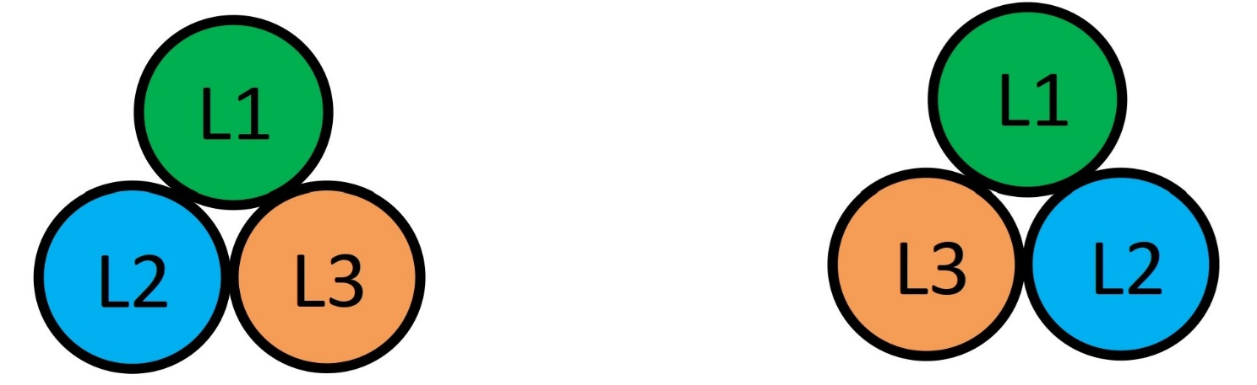
Picture 3 Trefoil cables formation type overview
The minimum distance of cable bundle/trefoil is 2x outer cable diameter (2d). Between parallel laid power cables minimum distances must be complied with along the entire laying distance (except for building-pass-through / penetrations). Power cables laid in parallel shall have the same cable lengths. A maximum cable length difference of 3% can be accepted if properly considered in cable dimensioning (de-rating). No free space is considered.
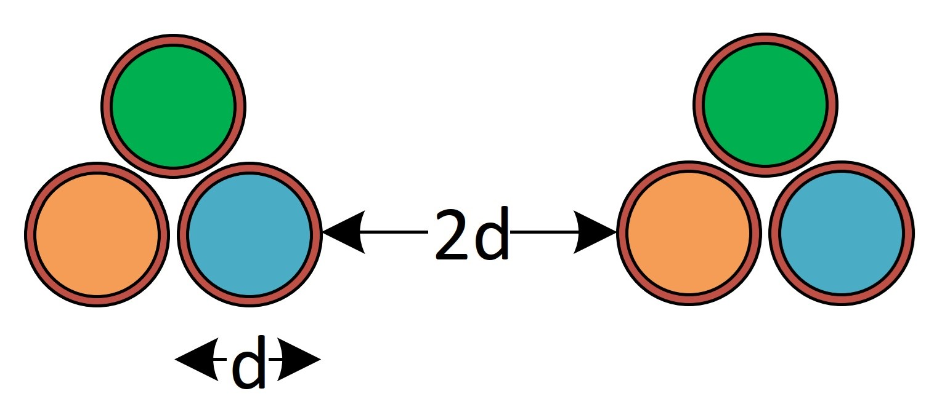
Picture 4 Minimum distance of cable trefoil
Free space is the unoccupied installation width across the bottom of the tray. It may lie between bundles, between a bundle and a side rail, or between groups laid along opposite rails. The result is a width percentage, rather than a cable area or volume percentage.

Space occupied by MV cable groups
MV phase cables may be grouped in triangular trefoil formation, with three phase cables per group. Occupied width uses the actual group footprints from Tray details, including cable diameters, formation, rotation and the selected intergroup spacing. Where trefoil clamps are enabled, the selected clamp envelope is reserved in the footprint. Separately routed cables remain part of the layout. The three phase diameters are not simply added as though all cables occupied one row.
The project cable-spacing setting is {{CABLESPACING}}. The installation requirement above specifies a minimum trefoil separation of 2d; the geometric calculation below reports the selected Tray details layout. The project option to count bundle spacing as free width is {{BUNDLESPACINGFREE}}. The formula adds the total group footprint width and the spacing counted as occupied. This free-width calculation does not verify the required separation or parallel cable lengths.
Occupied installation width: {{OCCUPIEDWIDTHFORMULA}}
The resulting occupied width is {{DIAMETERSSUM}}. An external grounding conductor is excluded from this width when it is mounted outside the side rail.

Cable tray free space
The free-width percentage is obtained by subtracting occupied width from tray width, dividing by tray width and multiplying by 100. Negative available width is reported as zero free width when the layout exceeds the tray width.
Percentage of free width: {{FREESPACE}}
The project free-width limits are a minimum of {{MINFREEWIDTH}} and a maximum of {{MAXFREEWIDTH}}. The final comparison with these limits is included in the assessment results below.

Assessment results

Load assessment
Capacity utilization is the design line load divided by the allowable line load at the selected support spacing, multiplied by 100. The remaining design-load capacity is the allowable load minus the design load. A negative reserve indicates overload.
Load capacity utilization: {{LOADUTILIZATIONFORMULA}}
Remaining design-load capacity: {{LOADRESERVEFORMULA}}
Design line load | {{DESIGNLOAD}} kN/m
Allowable line load | {{ALLOWABLELOAD}} kN/m
Load capacity utilization | {{LOADUTILIZATION}}
Remaining design-load capacity | {{LOADRESERVE}}
Remaining capacity percentage | {{LOADRESERVEPERCENT}}
Maximum allowable span within curve range | {{MAXALLOWABLESPAN}}
{{LOADVERIFICATION}}
This conclusion covers the specified distributed tray load and manufacturer curve. It does not establish the capacity of support brackets, fixings or anchors, or verify concentrated loads. It is not a short-circuit restraint or cable ampacity assessment; those checks require separate electrical and clamp design inputs.

Free space assessment
Calculated free width: {{FREEWIDTHRESULT}}. Project limits: minimum {{MINFREEWIDTH}}, maximum {{MAXFREEWIDTH}}.
{{FREEWIDTHVERIFICATION}}

Cable laying concept
{{FILLPICTURE}}
Picture 5 MV cable distribution trefoil groups and enabled clamps along the selected tray

